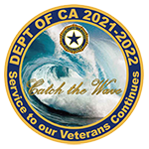
American Legion Auxiliary
Department of California
District 28
Music Bulletin
November 2021

Hello Musicians,
Our Department Chairman, Donna Scott, has asked how we are using music in our meetings.
If you have not already done so, please provide patriotic music for the openings or closings of your meetings. “God Bless America” or “America the Beautiful” are always good choices.
Please feel free to reach out if you have any questions.
Respectfully~
Robin
Robin Falkenberg
D28 Music Chairman

