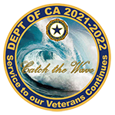
American Legion Auxiliary
Department of California
District 28
Leadership Bulletin
November 2021

Members~
Our Department Leadership chairman, Tracy Varnell-Fercho, is scheduling workshops for Spring 2022. This chairman would lie to schedule District 28 for some time in March. If your Unit would like to host the training, please let either President Liz or myself know.
All members are encouraged to take the ALA Academy courses on the National website. There is a wide variety of information available. If you have not already, please check them out.

Respectfully~
Robin
Robin Falkenberg

